Project: Currency Converter Website

Made by:

Mohammad Ziad Mohammed

Nagy Raouf

Medhat Ashraf Abdo Elhaddad

Hazem Hamada Abdellatif

Ahmed Abdalla Mohamed Madany

ABSTRACT

The product explained through the pace of this document is a basic dynamic website to help customers keep up with the recent changes in the currency market.

**Contents**

1. INTRODUCTION 1

1.1 Purpose 1

1.2 List of definitions 1

1.3 Scope 2

1.4 Overview 2

2. General Description 4

2.1 Product perspective 4

2.2 General capabilities 4

2.3 General constraints 4

2.4 User characteristics 5

2.5 Environment description 5

2.6 Assumptions and dependencies 5

2.6 Other resources needed 5

3. System requirements 5

3.1 Functional requirements 6

3.2 Non-functional requirements 6

4. Use-case diagram 6

5. Narrative Description of use cases 7

6. Data model 13

7. Requirements validation 15

8. Class model 16

9. State diagram 20

10. Interaction diagram 21

11. Detailed class diagram 22

12. Data model design 23

13. User interface design 24

14. Client-Object relation diagram 26

15. Detailed design 27

16. Testing 30

17. Estimated project cost 39

18.User Guide 40

Table of Figures:

Figure 1:use case diagram 7

Figure 2:Data Model 14

Figure 3:Class Diagram 20

Figure 4: State Diagram 21

Figure 5: Sequence Diagram 22

Figure 6:Detailed class diagram 23

Figure 7: Data model design 24

Figure 8: User Interface (main page) 25

Figure 9: User Interface (check rates page) 26

Figure 10:User Interface (message error 1) 26

Figure 11:User Interface (message error 2) 26

Figure 12:Client-Object relation diagram 27

Figure 13:Node Testing 33

Figure 14:Opening Main Page 34

Figure 15:No currency selected 35

Figure 16: one currency selected 35

Figure 17:non-numerical value handling 36

Figure 18: No value entered 36

Figure 19:Value output with float handling 37

Figure 20:Check rate page testing 37

Figure 21:About us page testing 38

Figure 22:Donate accepting numeric value and printing thanking massage 39

Figure 23:Donate not accepting non-numerical value 39

Figure 24:Home Page with labels 42

Figure 25:Step 1 (select currency) 43

Figure 26:Step 2 (Enter value) 43

Figure 27:Step 3 (Displayed Result) 43

Figure 28:Check Rates 44

Figure 29:Back to Home Page 44

Figure 30:About Us 45

Figure 31: About Us Page 45

Figure 32:Contact Us 46

Figure 33: Contact via Email 46

Figure 34:Donate 47

Figure 35: Use donate option 47

Table 1:Definitions 2

Table 2:Requirements validation 15

Table 3:User Guide 41

# 1. INTRODUCTION

This section gives a description and overview of the purpose and everything included in this document as well as a list of abbreviations and definitions. Also, a scope description of the project is briefly included.

## 1.1 Purpose

The purpose of this document is to build an online system to convert between different currencies and check the latest currency rates by means of accurate and concise modeling for all the components and interactions in the web application.

## 1.2 List of definitions

|  |  |
| --- | --- |
|  |  |
| Term | Definition |
| request/ RESPONSE | A digital request/response that conveys data which in essence is sent using a well-defined protocol. |
| user/ client | Someone who issues requests to a server either via a browser (to view a webpage) or any other kind of protocol-based requests in general. |
| ADMINSTRATOR | Someone who has administrative privileges to the server and able to give desired permissions to a system accordingly. |
| web portal | A website or service that offers broad array of resources and services such as email, forums or search engines. |
| Server | Its role is to listen for requests and send responses back accordingly to whoever is trying to communicate with it. |
| DATABASE | a structured set of data (a repository) that is stored in a meaningful manner (usually on a web server) and can be accessed in various ways. |
| render | Usually said when talking about a webpage (a template) that the server sends to the user or client to be able to view it via e.g. a browser. |
| Event | An action made by the user (e.g. a pressed button or a mouse click). |
| WEB SCRIPT | An operational block of code that is sent along with the rendered template to be able to perform extra functionality by being triggered when a specific event occurs. |
| framework | A software framework that provides a standard way to build and deploy applications. |

Table :Definitions

## 1.3 Scope

The “Currency converter” is a simple web application which helps people to convert between more than 160 different currencies and check for the latest currency rates. It’s absolutely free to use. However; users can donate to help keep the application up and running with helpful money.

Every 24 Hours the currency rates are updated in correspondence with the most recent ones, for that the administrator integrates the use of communicating with web-portals and banking websites in order to keep the information accurate.

All system information and currency rates are maintained in the backend which is located on the webserver.

## 1.4 Overview

The remainder of this document includes 17 sections. An overview of the system functionality and both system and components interactions are thoroughly documented. Section 2 introduces the general capabilities of the system and different types of stakeholders and their interaction with it. Further, the chapter also mentions the system constraints and assumptions about the product.

Section 3 provides the requirements specification in detailed terms and a description. Different specification techniques are used in order to specify the requirements more precisely for different audiences.

The following sections deal with the inner components of the system and going through their specific design. And finally sections about the testing process, cost estimation and user guide are included as well.

# 

# 2. General Description

This section illustrates the description of the project environment and its capabilities including any assumptions made about the product or general constraints.

## 2.1 Product perspective

The system will consist of a web server that handles requests and sends responses back accordingly. Data regarding the currencies need to be stored and accessible by the server, so that it can be displayed for the users or used to convert specified amounts of money between any two currencies, also Registered users’ information needs to be stored; ergo a database will essentially be needed for handling these tasks.

The web server will render web pages as per the link requested by the user/client and if needed the server will connect with the database to extract needed information as to sending a response.

The web server is also able to communicate online with banking websites or web-portals (which are specified by the administrator) to update the database and verify the information stored in it at specific times.

## 2.2 General capabilities

With the web application, users will be able to convert any specified amount of a selected currency to another via sending a request to the server with the amount to be converted placed in an input text field and wait for the response then show the result in an output text field once received. Further, Users are able to send a request for a web page to display the rates of all the supported currencies.

Users also can request a web page to provide them with information about the owners of the website, another to be able to contact owner of the webpage via email or sending a message, and another so that users can donate a specific amount of money to help the owners of the website. Users can have an identity on the website by signing up for an account.

## 2.3 General constraints

The main constraint of the system is the number of currencies supported by the web application which is about 160 different currencies. Non-functional constraints are: time frames (product should be ready to use in 10 days after the process begins) and sufficient resources as to have developers (if needed) work on the project.

An Internet connection is also a constraint on using the web application, Since the server renders web pages, handles different types of requests, and sends responses back. Then, it is crucial that there is an Internet connection to interact with the application.

## 2.4 User characteristics

There are two types of users that interact with the website: users that make use of the web application capabilities and administrators. Each of the two types has different use of the system so each of them has their own course of action.

The users only use the web application to do conversions between different currencies or make use of the general capabilities of the product as described before. Administrators on the other hand are responsible for keeping the database updated with accurate information and managing the overall system and make sure it behaves like expected.

## 2.5 Environment description

The operational environment of this product encompasses various aspects e.g. gaining general knowledge, keeping up with the currency recent changes which is of a great help if used in a domain that is related to economy, or convert between currencies that is usually associated with banking related activities.

## 2.6 Assumptions and dependencies

One assumption about the product is the user’s skills when interacting with the web application, and for that the interface should be designed to be relatively easy to interact with. Other assumption is: the users might want to contact the author or report to him about something, so such option ought to be made available.

The server may not need to handle too many requests, that being said, sophisticated hardware resources won’t probably be needed.

# 2.6 Other resources needed

Other specific resources needed for the project are: a database engine (will use SQLite) and a web framework using Flask which is written in Python.

# 3. System requirements

This sections goes into the very details of the specific requirements of the system (functional and non-functional requirements).

## 3.1 Functional requirements

- Convert specified amounts of a currency to another.

- Provide latest currency rates.

- An option to be able to donate to website owners.

- An option to be able to send a message to the owners or E-mail them.

- An option to be able to get information about the owners or company.

- Ability to have an account on the website.

- Administrative backend to control the system.

- Ability to updating the database with the latest currency rates.

## 3.2 Non-functional requirements

- The system should have fast response time.

- The system should tolerate common types of faults and be reliable.

- The web page should mainly support updated browsers.

- The system should be a 24/7 service.

- Memory required should just be enough for the database and keeping track of donations made by users and saving users information (>10GB).

- Preferred programming languages to be used are Python and JavaScript.

- Markup languages that will be used are HTML and CSS.

- The system should be easy to maintain in case anything happens.

- The system should be easily manageable and adjustable to any changes.

- The system must follow the Web Accessibility Standard “508 Law”, and the W3C website standards and the ISO/IEC 27001 information security standard.

- The system should comply to the company laws.

# 4. Use-case diagram

In this section, the use case diagram for the system is provided; showing all the system’s functionalities. Derived from the functional requirements; the use cases that the system exhibits are basically: logging in, signing up, checking the currency rates, converting between currencies, having database check for data, sending a message to the owners, donating to the owners, and showing an info page about the product and managers.

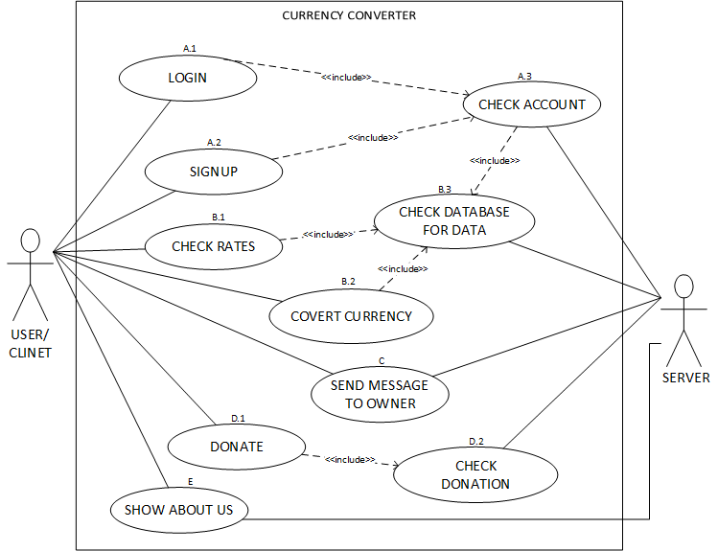

Figure :use case diagram

# 5. Narrative Description of use cases

Here, described are all the use cases included in the use case diagram that is provided in the previous section in great details.

|  |  |
| --- | --- |
| Use case | Login. |
| Related requirement | A.1 |
| Goal in context | User login to the system. |
| Precondition | User has an account. |
| Successful end condition | User successfully login to the system. |
| Failed end condition | User cannot enter the system. |
| Primary actor | User. |
| Secondary actor | System. |
| Trigger | The user clicks on the login button. |
| Included cases | Check Account |
| Main flow | |  |  | | --- | --- | | 1. | The user enters the user name and password. | | 2. | the user clicks on the login button. | | 3.  **include::Check Account** | system checks if the login credentials are valid. | | 4. | the user will be displayed a message that logged is succeeded. | |
| Extensions | 1.1 The user may misspell the name or the password.  2.1 The internet connection may drop during the process.  3.1 The system’s database or server may drop.  3.2 The system doesn’t check the login credentials.  4.1 The internet connection may drop during the process.  4.2 The user receives a message indicating failure. |

|  |  |
| --- | --- |
| Use Case | Signup. |
| Related Requirement | A.2 |
| Goal In Context | The user creates a new account. |
| Precondition | The user enters valid credentials and information. |
| Successful end condition | The user would have a new account. |
| Failed end condition | The user wouldn’t have a new account. |
| Primary Actor | User |
| Secondary Actor | System. |
| Trigger | The user clicks on signup button. |
| Included cases | Check Account |
| Main flow | |  |  | | --- | --- | | 1. | The user enters the signup page. | | 2. | The user enters the new user name and password and all the other required information. | | 3. | The user clicks on signup button. | | 4.  **include::Check Account** | The user’s submitted information is checked | | 5. | A new account is created and user information is added to the database. | |
| Extensions | * 1. The internet connection may drop during the process.   3.1 The internet connection may drop during the process.  4.1 The system’s database or server may drop.  4.2 The system doesn’t check the user’s data.  5.1 Account creation fails. |

|  |  |
| --- | --- |
| Use case | Check account. |
| Related requirement | A.3 |
| Goal in context | System check the user’s credentials whether for login or signing up. |
| Precondition | The user enters valid credentials. |
| Successful end condition | The user’s credentials are verified. |
| Failed end condition | The user’s credentials are not verified. |
| Primary actor | System. |
| Trigger | User’s credentials are provided for checking. |
| Main Flow | |  |  | | --- | --- | | 1. | The user provides their credentials/info to the system. | | 2. | the system checks if they are valid (cross reference with the database) or in case of a new account it checks whether specific data (e.g. username) already exists. | | 3. | The details are returned as verified and message passed to client. | |
| Extensions | 1.1 The internet connection may drop during the process.  2.1 The Database does not verify the details.  2.3 The system’s database or server may drop.  3.1 The internet connection may drop during the process.  3.2 The details are returned as unverified.  3.3 The server may drop. |

|  |  |
| --- | --- |
| Use case | Check rates. |
| Related requirement | B.1 |
| Goal In Context | The user will be able to get information about the latest currency rates. |
| Precondition | The user is in the homepage. |
| Successful end condition | The user will be able to view the webpage with the currency rates. |
| Failed end condition | The user won’t be able to view the webpage with the currency rates. |
| Primary actor | User. |
| Secondary actor | System. |
| Trigger | The user clicks the check rates button. |
| Included cases | Check database for data. |
| Main flow | |  |  | | --- | --- | | 1. | The user clicks on the check rate button. | | 2. **include::Check database for data** | The system checks the database for the currency rates and loads them. | | 3. | The system redirects the user to new web page where he can display the currency rates. | |
| Extensions | 1.1 The internet connection may drop during the process.  2.1 The system’s database or server may drop.  2.1 The system doesn’t check the database for the rates.  3.1 The internet connection may drop during the process.  3.2 The server may drop. |

|  |  |
| --- | --- |
| Use case | Convert currency. |
| Related requirement | B.2 |
| Goal in context | Get the amount of money converted in terms of another currency. |
| Precondition | The user selects the “converted from” currency and specifies its amount then selects the “converted to” currency. |
| Successful end condition | The system will convert the money amount. |
| Failed end condition | The system won’t convert the money amount. |
| Primary actor | User |
| Secondary actor | System |
| Trigger | The user clicks the convert button. |
| Included cases | Check database for data. |
| Main flow | |  |  | | --- | --- | | 1. | The user selects both currencies. | | 2. | The user clicks on the convert button | | 3. **include::Check database for data** | The system checks the database for the corresponding rates of the currencies. | | 4. | The system converts the input amount accordingly | | 5. | The system display the result for the user. | |
| Extensions | 2.1 The internet connection may drop during the process.  3.1 The system’s database or server may drop.  3.1 The system doesn’t check the database  4.1 The server may drop.  5.1 The internet connection may drop during the process.  5.2 The server may drop. |

|  |  |
| --- | --- |
| Use case | Check database for data. |
| Related requirement | B.3 |
| Goal in context | Get/add data from/to the database. |
| Precondition | An action that requires using the database is triggered. |
| Successful end condition | Data will be returned/added from/to the database. |
| Failed end condition | Data won’t be returned/added from/to the database. |
| Primary actor | System. |
| Trigger | The user invokes an action that requires the system to get data from the database. |
| Main flow | |  |  | | --- | --- | | 1. | The System requires verification for data from the database. | | 2. | Connection with database is made. | | 3. | Data is found and returned. | |
| Extensions | * 1. The server may drop.   2.1 The system’s database or server may drop.  2.2 The system doesn’t connect with the database.  3.1 The system’s database or server may drop. |

|  |  |
| --- | --- |
| Use case | Send message to owner. |
| Related requirement | C |
| Goal in context | The user sends a message/email to the website owners. |
| Precondition | The user is in the contact page. |
| Successful end condition | The user is able to send the message. |
| Failed end condition | The user is enable to send the message. |
| Primary actor | User. |
| Secondary actor | System. |
| Trigger | The user clicks the send message button. |
| Main flow | |  |  | | --- | --- | | 1. | The user enters his/her message to be sent in the text area. | | 2. | The user clicks on the send message button. | | 3. | The system receives the user message. | |
| Extensions | 2.1 The internet connection may drop during the process.  3.1 The server may drop. |

|  |  |
| --- | --- |
| Use case | Donate. |
| Related requirement | D.1 |
| Goal in context | The user can send a donation to the owners. |
| Precondition | The user is in the donate page and enters a valid donation. |
| Successful end condition | The donation is sent successfully. |
| Failed end condition | The donation is not sent. |
| Primary actor | User. |
| Secondary actor | System. |
| Included cases | Check donation. |
| Trigger | The user clicks on the donate button. |
| Main flow | |  |  | | --- | --- | | 1. | The user selects the payment method and the value of money to donate with. | | 2. | The user clicks on Donate button. | | 3.  **include::Check Donation** | The system checks the validity of the donation. | | 4. | A message indicating success is displayed for the user. | |
| Extensions | 2.1 The internet connection may drop during the process.  3.1 The server may drop.  3.2 The system does not check or verify the donation.  4.1 A message indicating failure is displayed for the user.  4.2 The server may drop.  4.3 The internet connection may drop during the process. |

|  |  |
| --- | --- |
| Use case | Check donation. |
| Related requirement | D.2 |
| Goal in context | The system validate the user’s donation. |
| Precondition | The user submits the donation method and amount. |
| Successful end condition | The user’s donation will be collected successfully. |
| Failed end condition | The user’s donation won’t be a collected and an error would be produced. |
| Primary actor | System. |
| Secondary actor | User. |
| Trigger | The user clicks the “donate” button |
| Main flow | |  |  | | --- | --- | | 1. | The system is provided the information entered by the user and the method of payment. | | 2. | The system checks the validity of the payment. | | 3. | The system returns verification on the transaction process. | |
| Extensions | 1.1 The server may drop.  2.1 The server may drop.  2.2 The user’s account is out of balance.  2.3 The system doesn’t check or verify the information.  3.1 The system returns indication of failure. |

|  |  |
| --- | --- |
| Use case | Show about us |
| Related requirement | E |
| Goal In Context | Provide the user with information about the page and the owner. |
| Precondition | User is able to navigate to the about us page. |
| Successful end condition | User is provided the webpage with the information. |
| Failed end condition | User is not provided the webpage with the information. |
| Primary actor | User. |
| Secondary actor | System. |
| Trigger | The user clicks on About us link. |
| Main Flow | |  |  | | --- | --- | | 1. | The user clicks on About us link. | | 2. | The system displays the information | |
| Extensions | 1.1 The internet connection may drop during the process.  2.1 The server may drop.  2.2 The internet connection may drop during the process. |

# 6. Data model

This section primarily describes the data model adopted in the system; an EER diagram that represents the entities including all the attributes in each one and the relations between different entities is provided and includes: one entity that represents the currency with its attributes (i.e. name and US dollar value) and another that represents the user and its corresponding attributes (i.e. username, password, full name, and email address); Further, the relation between the two entities is described in the diagram. This idea of the data model will be used to handle the organization of the database for the system to connect with it and get useful information in runtime.

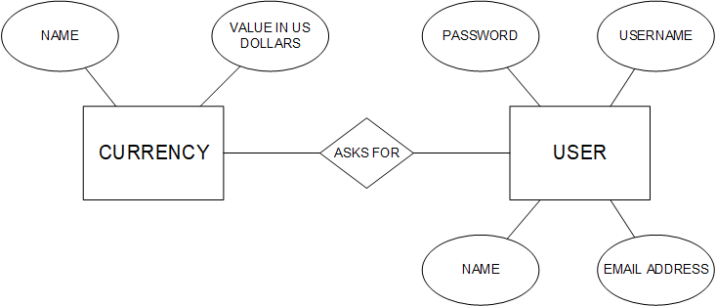

Figure :Data Model

# 7. Requirements validation

This section is concerned with the relationships among the functional requirements provided in a previous section, their sources, and the system design, for that the traceability matrix for the functional requirements is provided as follows.

|  |  |  |  |  |  |  |  |  |
| --- | --- | --- | --- | --- | --- | --- | --- | --- |
|  | Convert | Currency  rates | Donate | Send  message | Website  information | Have  Account | Backend  Control | Updated  database |
| Convert |  | R |  |  |  |  |  | D |
| Currency rates |  |  |  |  |  |  | D | D |
| Donate |  |  |  |  |  |  | D |  |
| Send message |  |  |  |  |  |  | D |  |
| Website information |  |  |  |  |  |  |  |  |
| Have  Account |  |  |  |  |  |  | D | D |
| Backend  Control |  |  |  |  |  |  |  |  |
| Updated  database |  |  |  |  |  |  |  |  |

Table :Requirements validation

# 8. Class model

Details on both the normal and exception scenario when using the web application are provided here, also the nouns extraction and CRC methods are used to identify classes’ names.

Normal Scenario:

1. user attempts to open the website from their browser.

2. user successfully opens the website displaying the homepage.

3. user enters the value of money needed to be converted in the first input textbox.

4. user selects the currency to convert from, via the first currency selection bar.

5. the selection menu opens and the user have 160 different currencies to choose from.

6. user selects the currency needed to convert to, by using the same way.

7. user click on the “Convert” button and sends the form data.

8. correct input are given to the text fields and selection bars.

9. the application extracts the required data from the database.

10. the application does the conversion.

11. the application sends the results back.

12. result value is now displayed in the second box for the user.

13. the user clicks on “check rates” link.

* The browser sends a request for the web page with the specified link.
* the application extracts the required data from the database.
* A page viewing the currency rates is rendered for the user.

14. the user clicks on “About Us” link.

* The browser sends a request for the web page with the specified link.

A page containing information about the owners is rendered for the user.

15. the user clicks on “Donate” link.

* The browser sends a request for the web page with the specified link.
* The donation page is rendered for the user.
* The user enters a value of money.
* The user chooses the payment method.
* The user clicks the donate button.
* The application shows a message to the user indicating the result of transaction.

16. the user clicks on “Contact us” link

* The browser sends a request for the web page with the specified link.
* The user clicks on contact via email and an email agent opens to send email.
* The user writes a message for the owner in the text area.
* The user clicks on “Send message” button.

Exception Scenario:

1. user attempts to open the website from their browser.

2. user fails to open the website due to server accidently shutting down.

**Noun Extraction:**

**Identified nouns:** Application, Form, Currency selection bar, Convert button, button, Donate button, Link.

**Excluded nouns:** Currency selection bar, donate button, convert button.

**Candidate classes:** Application, fill-in form, Button, Link.

**Additional classes:** Convert form.

CRC Method:

|  |
| --- |
| Class  **Application** |
| Responsibility   1. Renders templates (web pages) 2. Handles the form’s data. 3. Check the validity of the information. 4. Sends data to client/browser. 5. Sends data to the **Form.** |
| Collaboration   1. Class **Link** 2. Class **Form** 3. Class **Button** |

|  |
| --- |
| Class  **Convert form** |
| Responsibility   1. Contains the numerical value/selected currencies entered by the user 2. Receives the result returned by the Application. 3. Display the result in the output text field. |
| Collaboration  Class **Application**  Class **Button** |

|  |
| --- |
| Class  **Button** |
| Responsibility   1. Sends the data contained in the form. 2. Performs actions on being clicked. |
| Collaboration   1. Class **Application** 2. Class **Form** |

|  |
| --- |
| Class  **Link** |
| Responsibility   1. Sends request to the Application to open a webpage on being clicked |
| Collaboration  Class **Application** |

|  |
| --- |
| Class  **Fill-in form** |
| Responsibility   1. Contains the input to be submitted. |
| Collaboration  Class **Application**  Class **Button** |

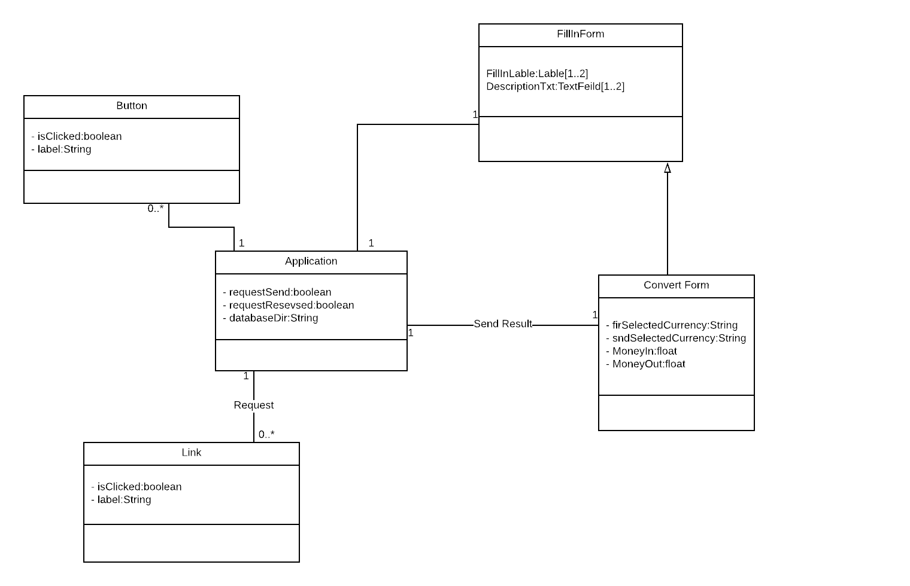

Figure :Class Diagram

# 

# 9. State diagram

This section provides the detailed state diagram of the whole system showing how the user can move on from one state to another (e.g. navigation between different pages).

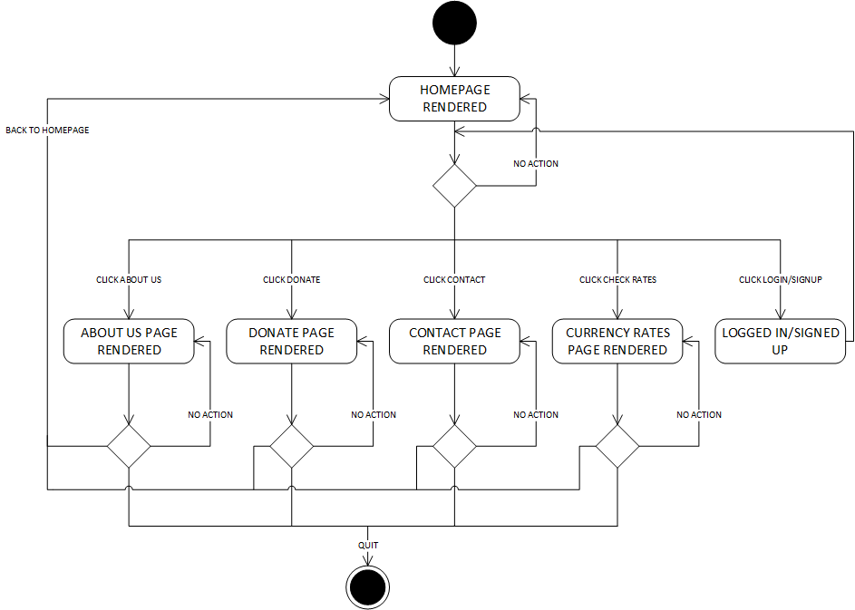

Figure : State Diagram

# 

# 10. Interaction diagram

This section provides the interaction diagram that is adopted by the use of a sequence diagram that describes in details the exchange of messages and interactions between all the objects/classes within the web application covering all system’s use cases (as provided in section 4).

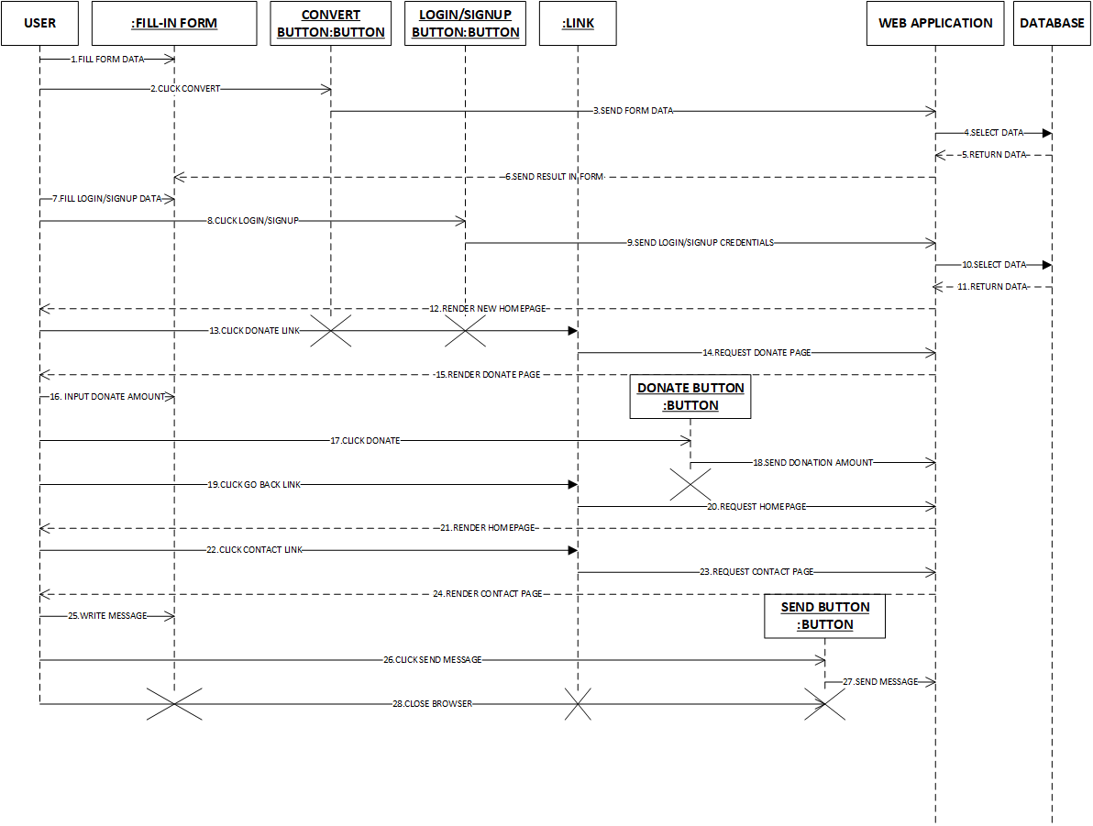

Figure : Sequence Diagram

# 11. Detailed class diagram

This section illustrates the class diagram of the system that contains classes, their relationships, attributes, and operations. Attributes’ types, operations’ arguments, arguments’ types, and return types of each operation are provided as well. Methods and attributes are derived in a straightforward manner from the class model as described in section 8. Some user-defined types are used such as a “rendered template” object which contains the content of the webpage in text that is going to be sent to the client to be able to display via (e.g. a browser) with all the runtime variables rendered in the template, also a “database object” which mainly represents an object that has information about the database (i.e. its location on the webserver and type) and some methods associated with it to be able to communicate with the adopted database engine.

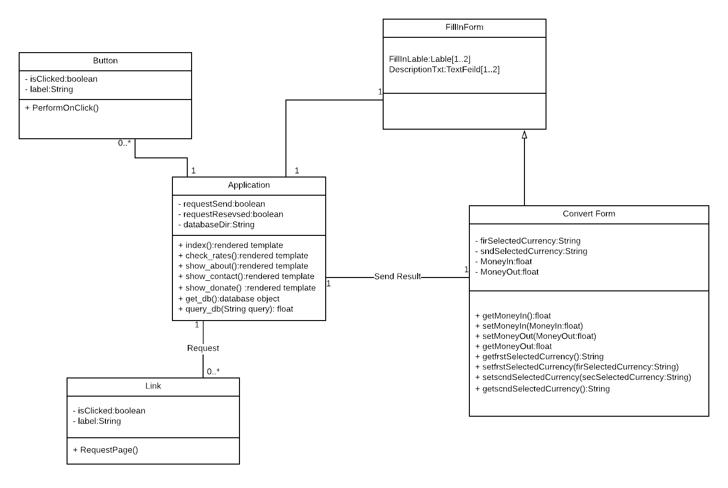

Figure :Detailed class diagram

# 12. Data model design

In this section, the detailed schema used by the data model That in essence shows the tables in the database, their attributes, and the primary keys in each table.

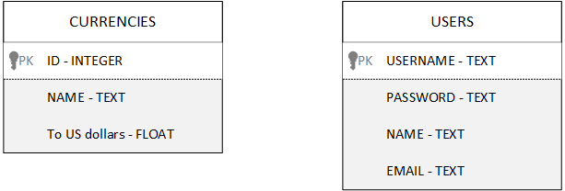

Figure : Data model design

# 13. User interface design

This section mainly describes the UI styles adopted in the web pages’ design. In the main interface: menu selection and fill-in form are adopted for the users to select the two currencies they would like to convert between, and then in the form: there are two text fields, one for the users to input the desired amount to convert and another to display the converted result. A referral button in the upper left corner of the page labeled “check rates” is for redirecting the users to another page that display the currency rates in a table. At the lower left corner of the page there are some hyperlinks with meaningful labels for the user to click on to redirect them to the corresponding page accordingly. Helpful error messages are shown in case of bad entries or else.

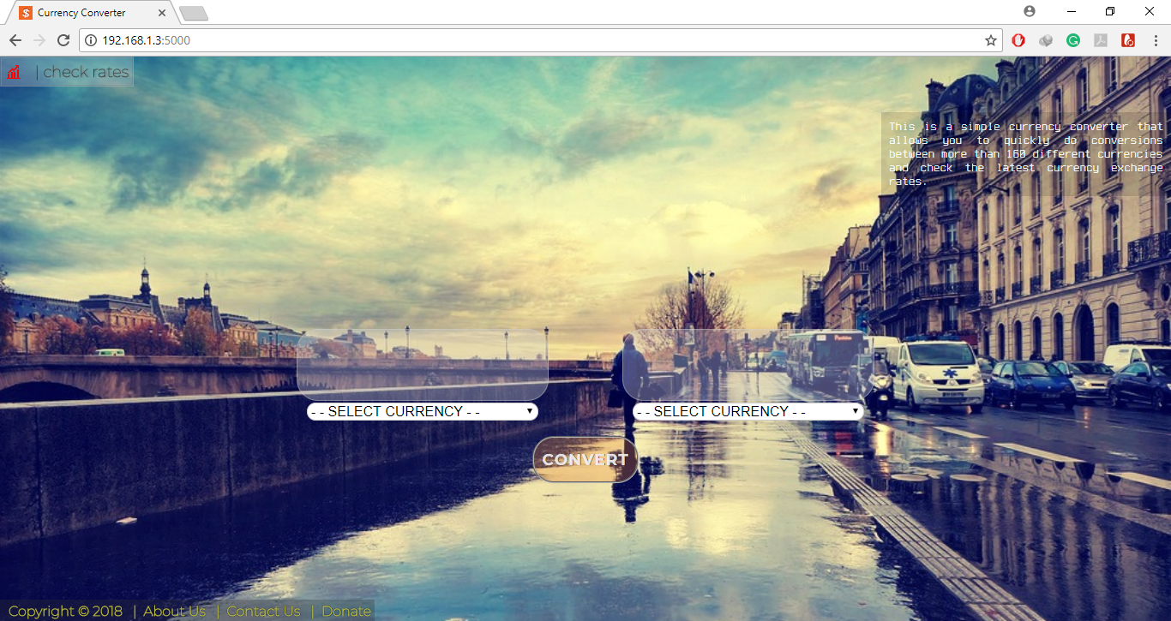

Figure : User Interface (main page)

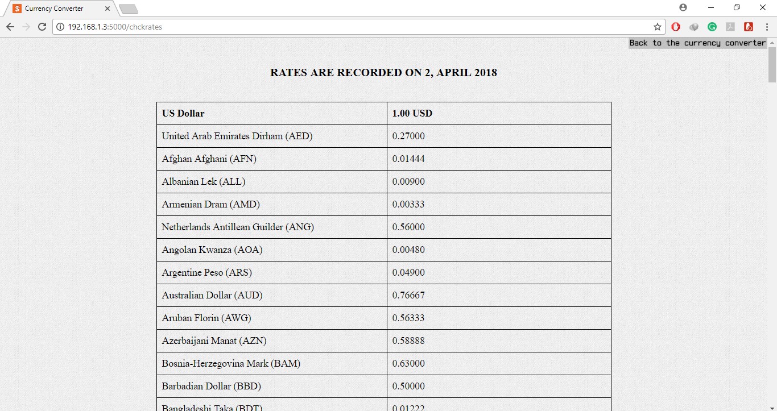

Figure : User Interface (check rates page)

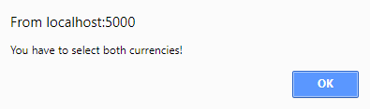

Figure :User Interface (message error 1)

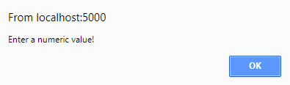

Figure :User Interface (message error 2)

In the contact web page interface: there’s a text area where you can input the message to send to the website owner and a button to send the message. And finally the donate web page interface has a form where you can input the desired amount for donation and a button for submission.

# 

# 14. Client-Object relation diagram

Shown here is the diagram that demonstrates the relation between objects and the main method and how they are instantiated.

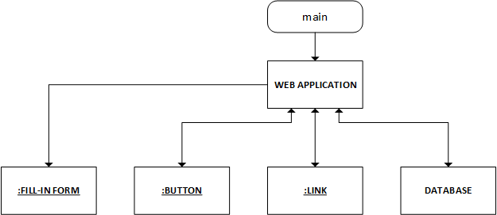

Figure :Client-Object relation diagram

# 15. Detailed design

In this section Program Description Language (PDL) is used to detail major operations defined in the classes of the project.

Class Application

{

Methods: -

void get_db()

{

return currencies_database;

}

float query_db(string query)

{

Selects a currency in the database using the query parameter;

return the value of the currency in US dollars;

}

void index()

{

If (convert button clicked)

{

check sent data;

get the value of first and second currencies and moneyIn;

calculate the result using ((first/second) * moneyIn);

render the mainpage with the result;

}

else Render and show mainpage;

}

void check_rates()

{

show check page;

view database in tabular form for all currencies;

}

void show_about()

{

show about us page;

}

void show_contact()

{

show contact page;

}

void show_donate()

{

if(donate button pressed)

{

if(float) write thanks message, and render donate page;

}

else show donate page;

}

}

Class Convert form

{

Methods:-

float getMoneyIn()

{

return MoneyIn;

}

float getMoneyOut()

{

return MoneyOut;

}

String frstSelectedCurrency()

{

return frstSelectedCurrency name;

}

String scndSelectedCurrency()

{

return scndSelectedCurrency name;

}

void setMoneyIn(float)

{

set MoneyIn value;

}

void setMoneyOut(float)

{

set MoneyOut value;

}

void frstSelectedCurrency(String)

{

set frstSelectedCurrency name;

}

void scndSelectedCurrency(String)

{

set scndSelectedCurrency name;

}

}

Class Button

{

Methods: -

performOnClick()

{

perform the action associated with the button;

}

}

Method send_data()

{

//action listener for the convert button

If(currencies are not selected) alert user to select currencies;

If(textfield value is not a number) alert user to input a number;

If(server responses with a result) Form.setMoneyOut(result);

send the moneyIn value to the server to be converted;

}

Class Link

{

Methods:-

RequestPage()

{

requests the page associated with that link;

}

}

# 16. Testing

Abstract: As we are working on an object oriented software (the building blocks are the classes; ergo, we will test every method in each class via white box testing during the unit testing phase, then we will test all the interfaces and collaboration between objects during the integration and system testing phases). Incremental method is going to be adopted to avoid big bang mistakes, and bottom up testing will be started to decrease the number of stubs and drivers needed.

I. Unit testing: -

Link class:

**Testing method: -** Link class testing is straightforward as it’s only containing one method (request_link).

**Test cases or scenarios: -** The only scenario available is to click each link and make sure it renders a page and that it is the right page.

**Criteria: -** None.

**List of links: -** Index, check rates, donate, about us, contact us, and back to main page.

**Result :-** All links are working and rendering the right page assossiated with them.

Button class:

**Testing method: -** Button class only contain one method (performOnClick).

**Test cases or scenarios: -** The only scenario available is to click each button inside the application and make sure it calls the right listener and performs the correct operation.

**Criteria: -** None.

**List of Buttons: -** Convert button and Donate button.

**Result : -** All buttons are working and call the right action listener assossiated with them with the expected behaviour.

**Convert form** class**:**

**Testing method: -** Form class contains a group of setters and getters methods.

**Test cases or scenarios: -** all that class methods are pretty straightforward and need minimal to none test cases in unit testing phase.

**Criteria: -** none

**List of Forms: -** Convert form, donate form, login/signup form.

**Result :-** throw to application class.

P.S:- all above classes are tested in the integration phase while it interacts with the Application class. Application class as a main class is tested through integration testing and system testing.

**II. Integration** testing**:**

Application **class:**

**Testing method: -** the Application class is the main class; therefore, it is used.

**Test cases or scenarios: -**

There are 2 main tests in that class: -

1. Make sure it renders the different pages correctly.
   * 1. Same as link class testing for each link.
2. Test every page functionality.
   * 1. convert form and convert button works.
     2. check rates page view a tabular form with all the rates stored in the data base.
     3. donate button works correctly.
     4. Send message button works correctly.

**Criteria: -**

**i- Convert form and button works: -**



Figure :Node Testing

**Every branch test cases: -** {<none selected>,<frstselected>,<firstselected,scndselected>,<frstselected,scndselected,non numeric value entered>,<frstselected, scndselected, numeric value entered>}

**Paths test cases: -** {<none selected>,<frstselected>,<firstselected,scndselected>,<frstselected,scndselected,non numeric value entered>,<frstselected, scndselected, numeric value entered>}

**Infeasible paths: -** none

**Paths covered: -** { <1,2,4>,<1,2,3,4>,<1,2,3,5,7>,<1,2,3,5,6,7>,<1,2,3,5,6,8,9>}

System testing:-

**openning the Application:-**

An attached readme text file with a step by step of how to run the get the server running so that users can connect to the server and view the website.

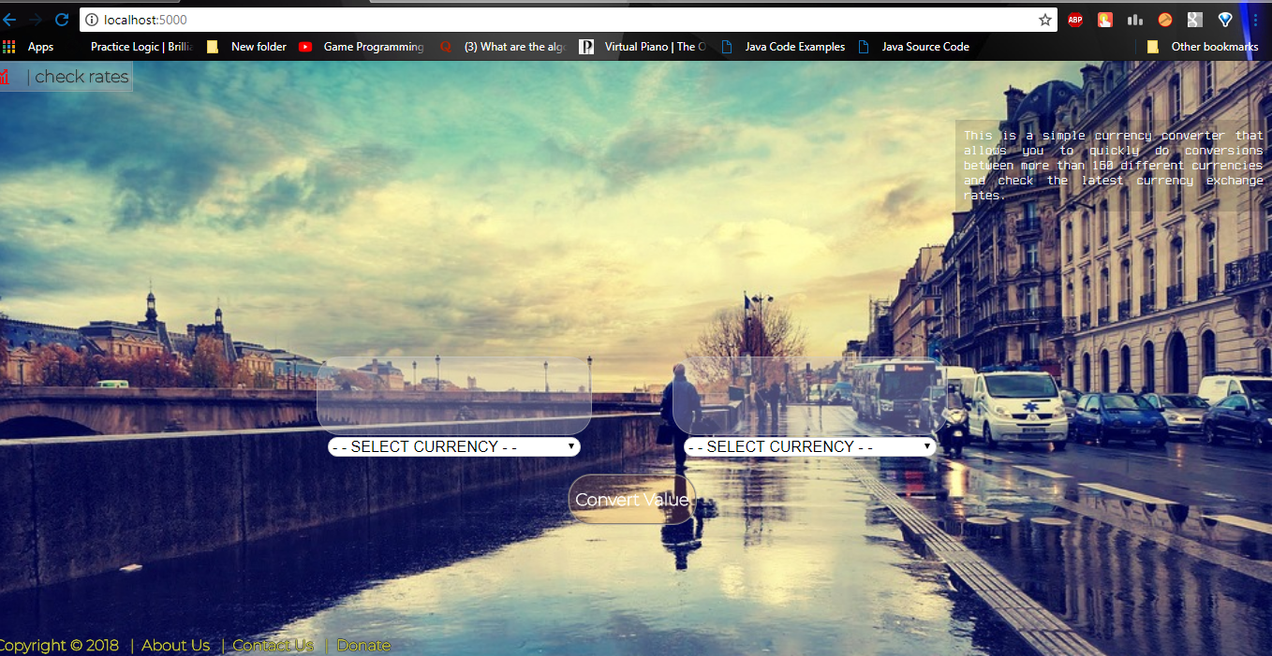

Figure :Opening Main Page

**Main Page Testing:**

Trying to convert without entering any value of money or any currency.

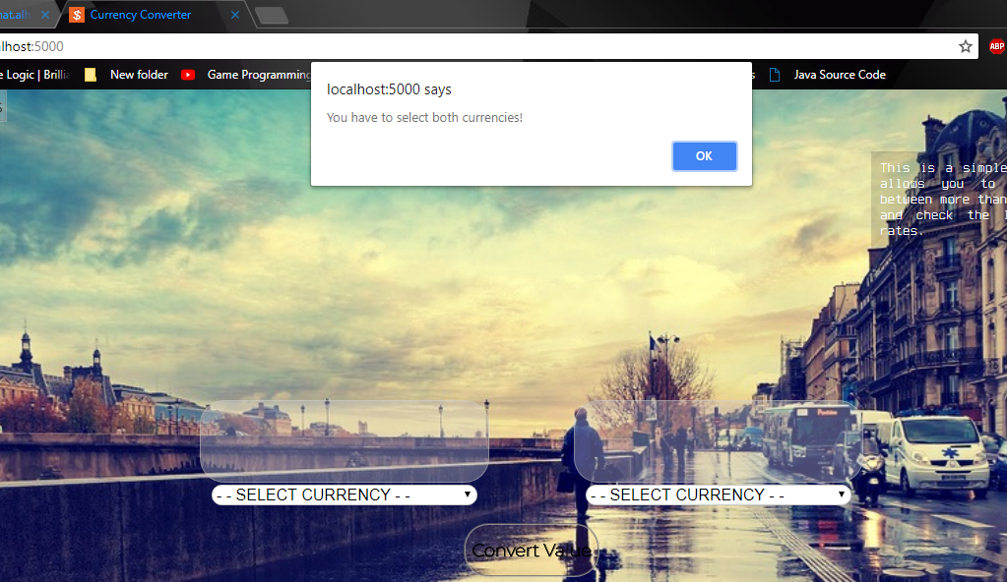

Figure :No currency selected

Try converting without entering both currency and values

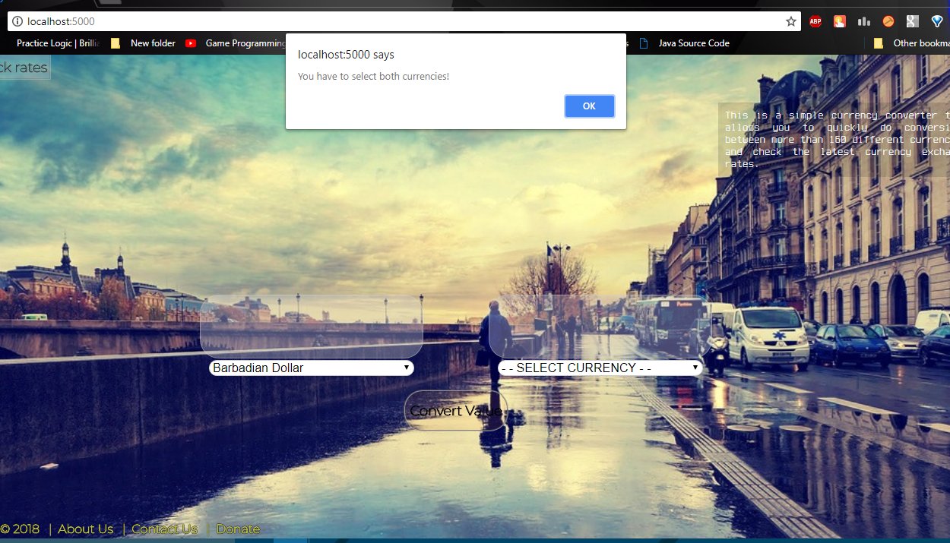

Figure : one currency selected

The system’s result when entering a non-numerical value.

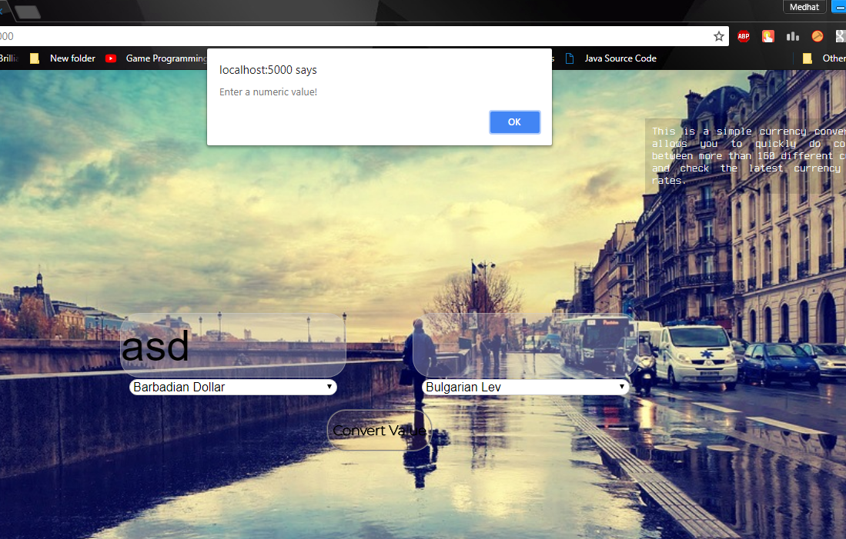

Figure :non-numerical value handling

The system’s result without entering numerical value

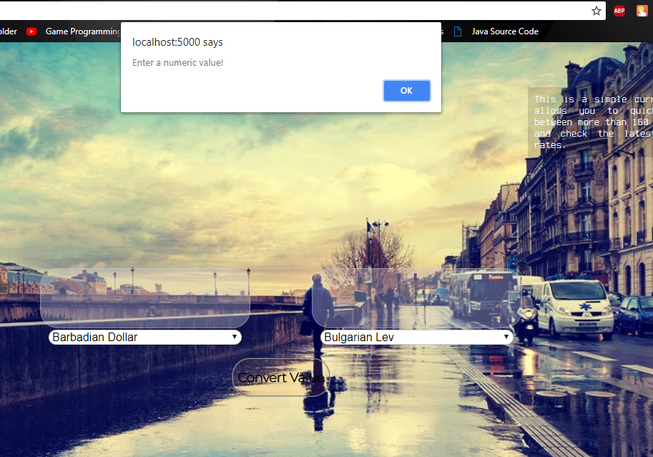

Figure : No value entered

The system’s result when entering float value.

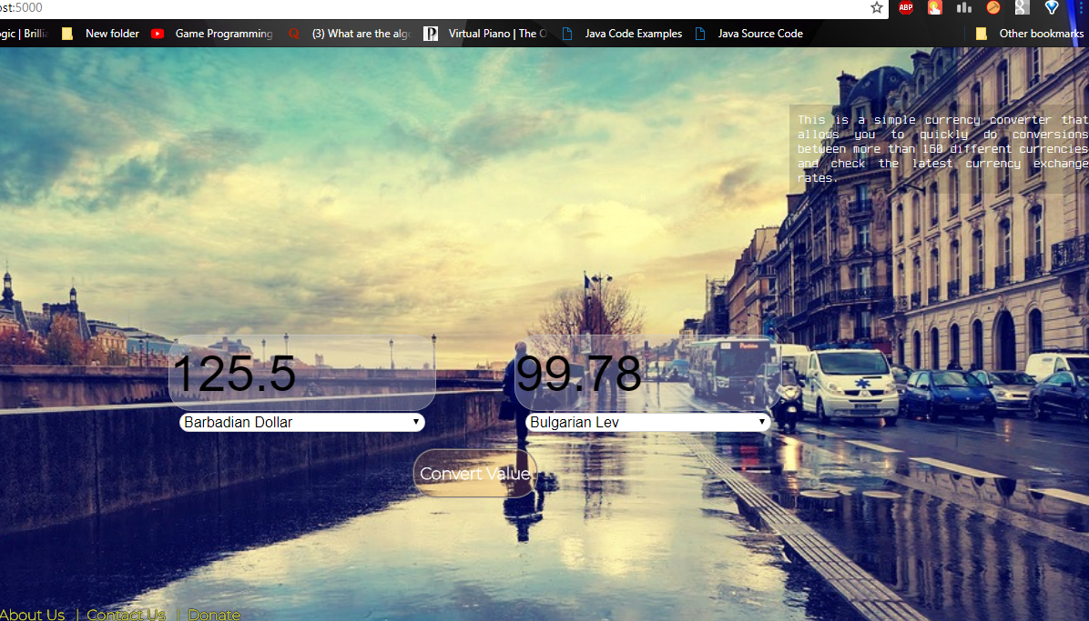

Figure :Value output with float handling

When pressing the check rates in the main page.

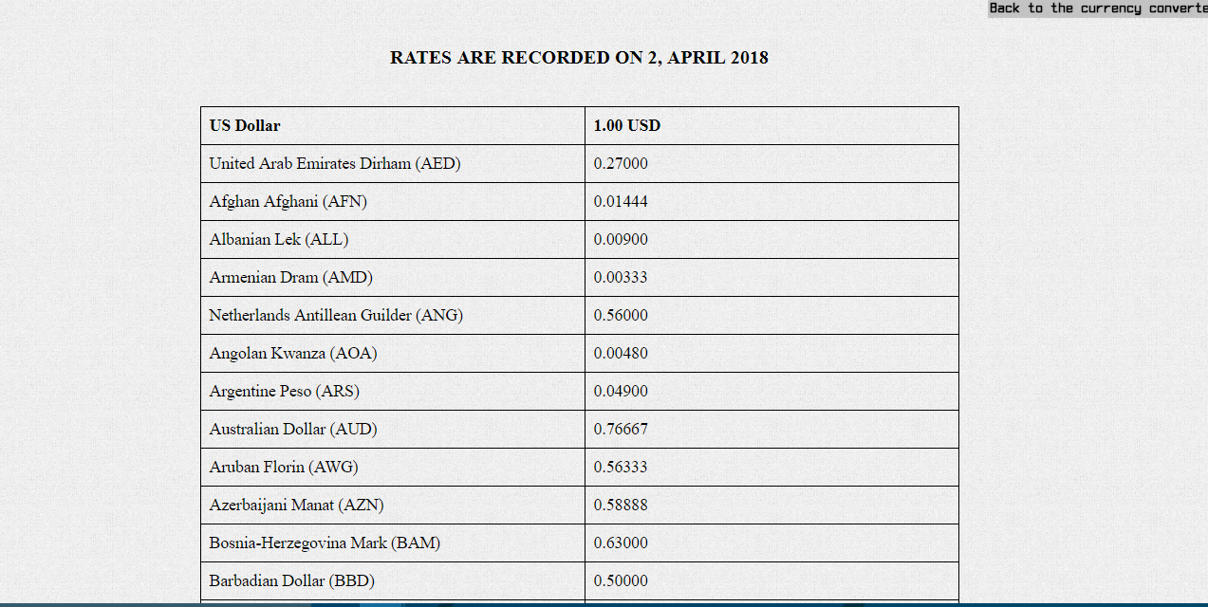

Figure :Check rate page testing

When pressing the Contact Us in the main page.

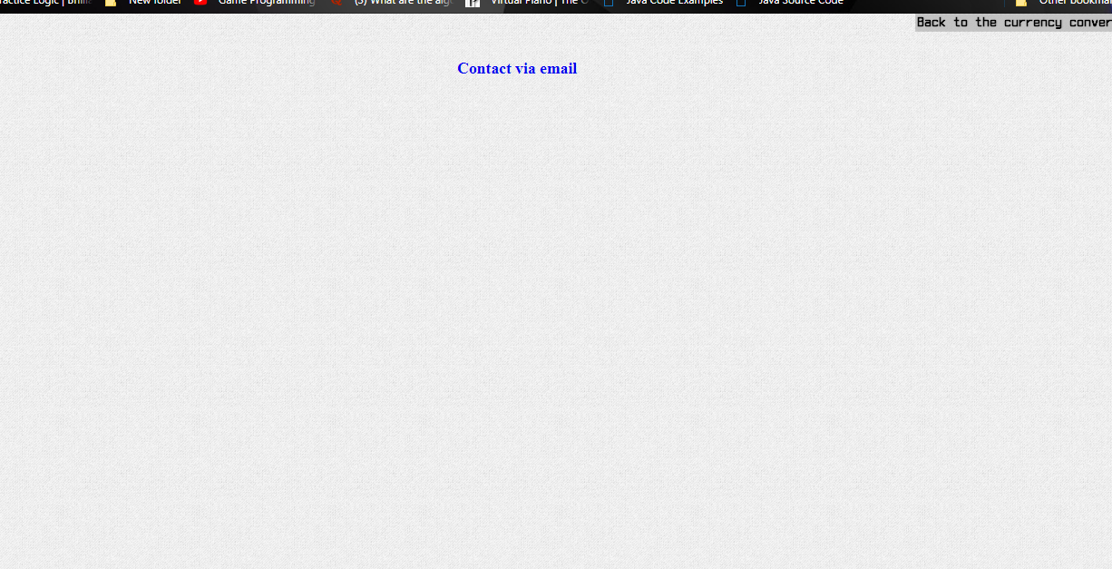

Figure21:Contact Us page testing

When pressing the About Us in the main page.

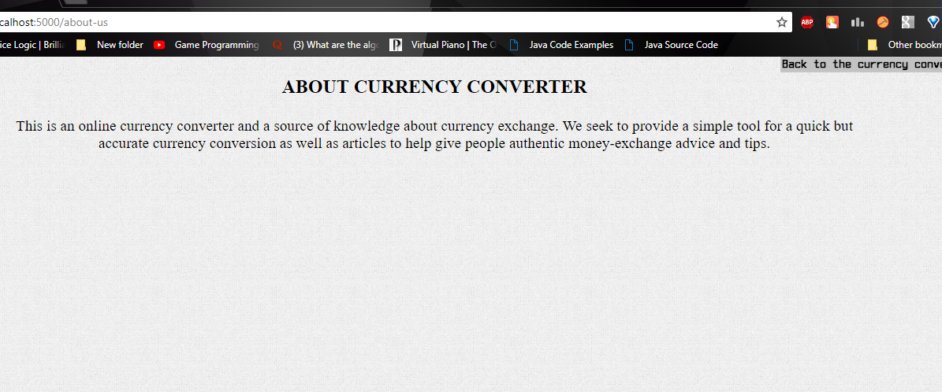

Figure :About us page testing

When pressing the Donate in the main page.

* Result of entering a numerical value in the donation bar.

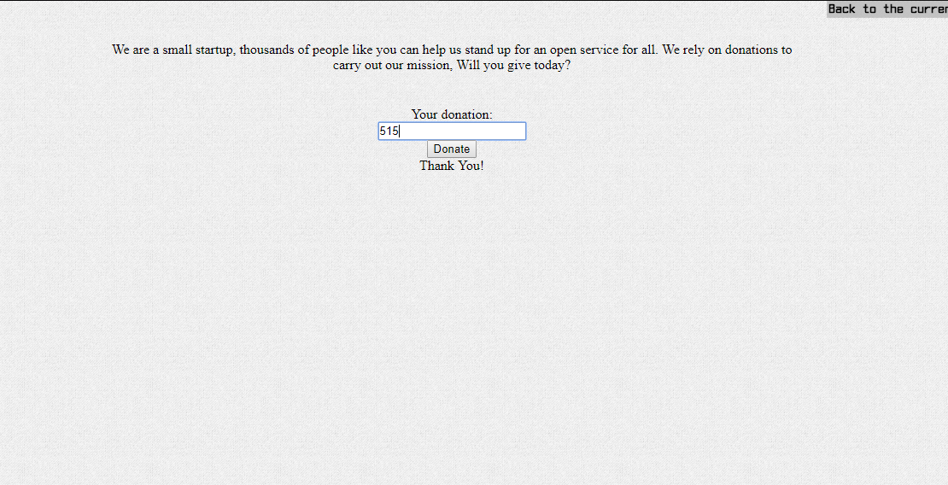

Figure :Donate accepting numeric value and printing thanking massage

* Result of entering a non-numerical value in the donation bar.

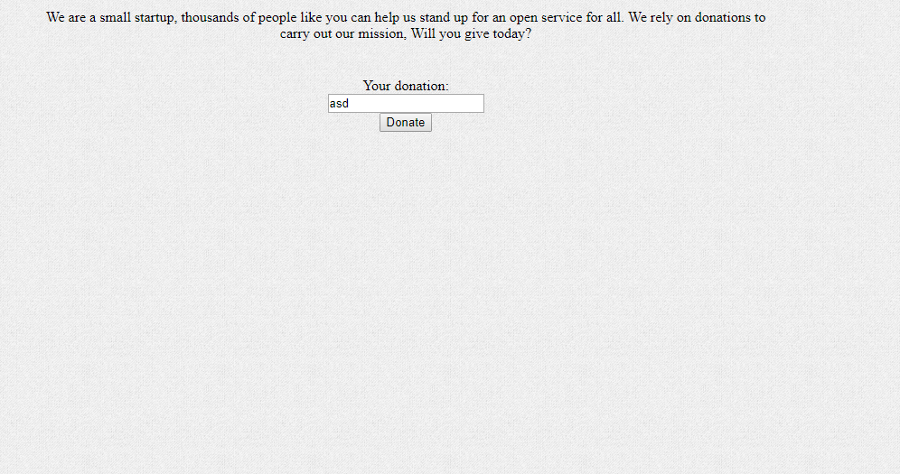

Figure :Donate not accepting non-numerical value

# 17. Estimated project cost

Below is the cost estimation for the currency converter website. According to COCOMO II, cost is estimated based on variables such as organization-dependent constant, Size of code (KLOC), combined spent effort, and multipliers that reflect the product, process and people. This product was developed from scratch and finished within two weeks from start. The software was coded by a developer of moderate experience. There were no special facilities included. The software was coded in python. Its error tolerance is very high; hence, it is very reliable. These are the changed multiplier values:

RCPX – high = 1.42

PDIF – low = 0.9

SCED – medium = 1.25

Organization constant (A) = 2.94

Size = 1.421 KLOC

Exponent B = 1.1

Effort = PM = A x Size^B x M = 2.94 * (1.421^1.1) * 0.9 * 1.42 * 1.25 = 6.9126 Person-months

# 18.User Guide

Welcome to currency converter website. This web application is comprised of 7 pages:

|  |  |
| --- | --- |
| **HomeHome** | This is the main page of the website. It contains the currency converter. |
| **Upward trendCheck Rates** | This page contains the rates of currencies, relative to US Dollar. |
| **InformationAbout us** | Contains a brief description of the website and what it does. |
| **EmailContact us** | Provides the e-mail address to contact in case of any issues or inquiries. |
| **MoneyDonate** | To send donations, to keep the website running and maintain it on a timely basis. |

Table :User Guide

**Home Page – Currency converter**

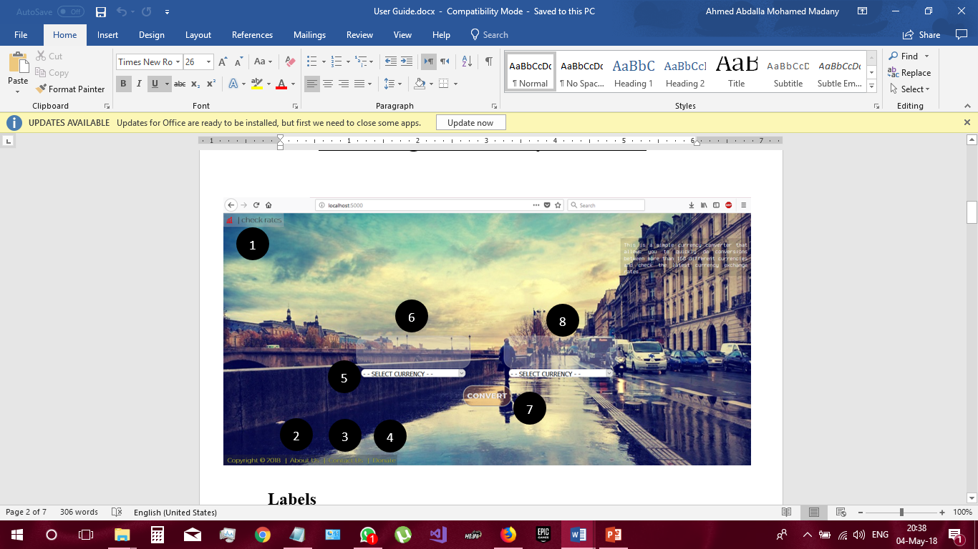

Figure :Home Page with labels

**Labels**

1. “Check Rates” button.

2. “About Us” button.

3. “Contact Us” button.

4. “Donate” button.

5. Currency choice scroll bar.

6. Amount to be converted text box.

7. “Convert” button.

8. Results box.

Converting Currencies

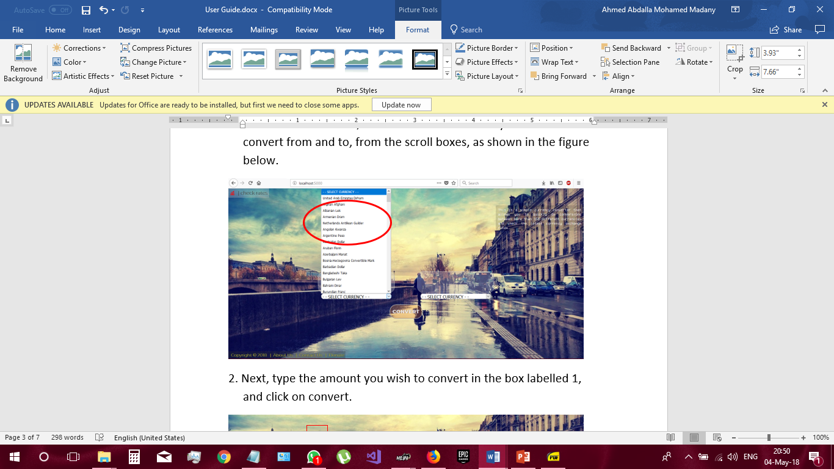1. To convert currencies, first select the currencies you wish to convert from and to, from the scroll boxes, as shown in the figure below

Figure :Step 1 (select currency)

2. Next, type the amount you wish to convert in the box labelled 1, and click on convert.

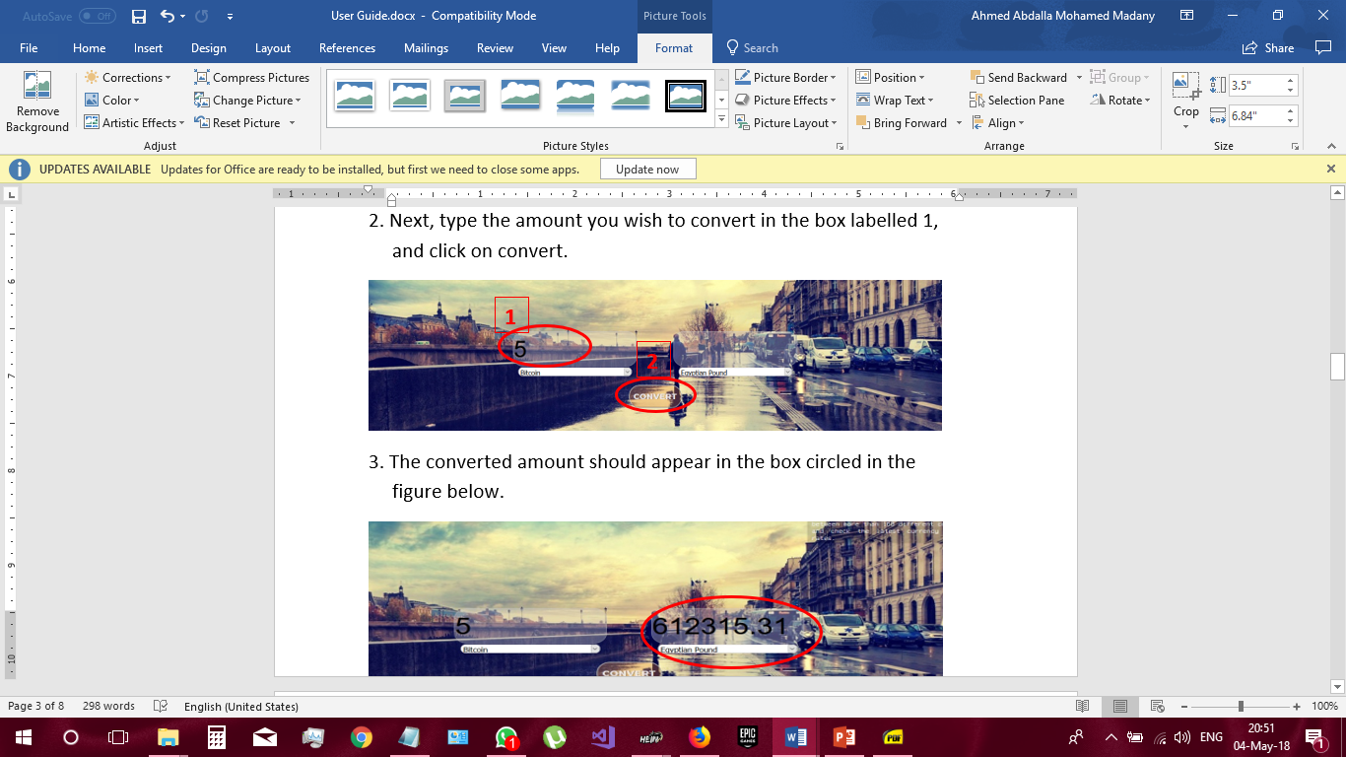

Figure :Step 2 (Enter value)

3. The converted amount should appear in the box circled in the figure below.

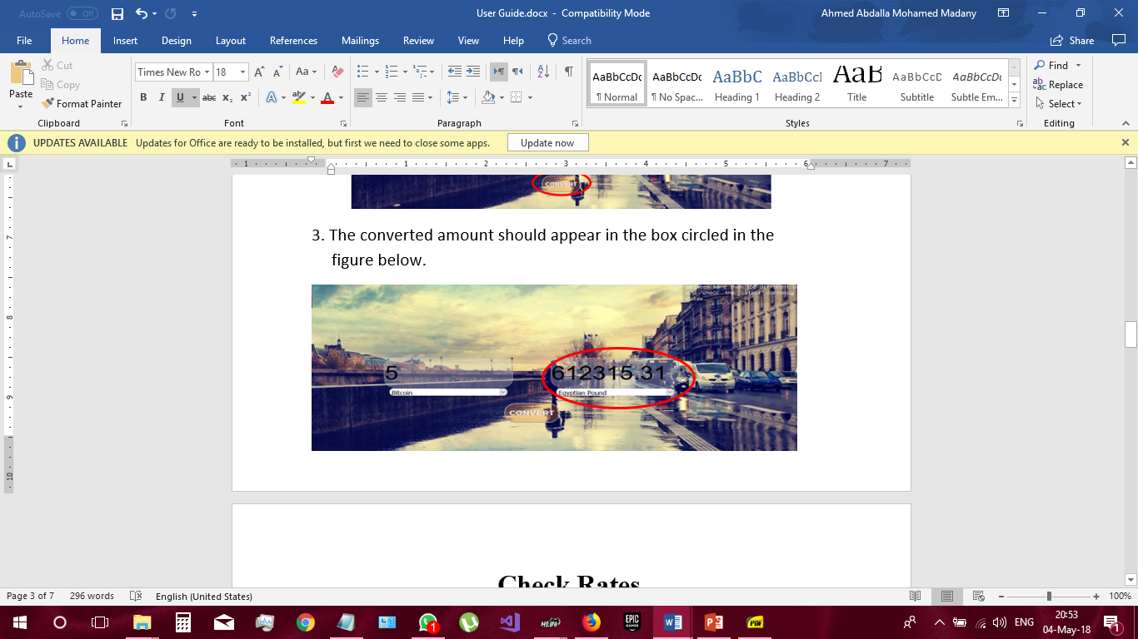

Figure :Step 3 (Displayed Result)

**Check Rates**

1. Click on “check rates” button.

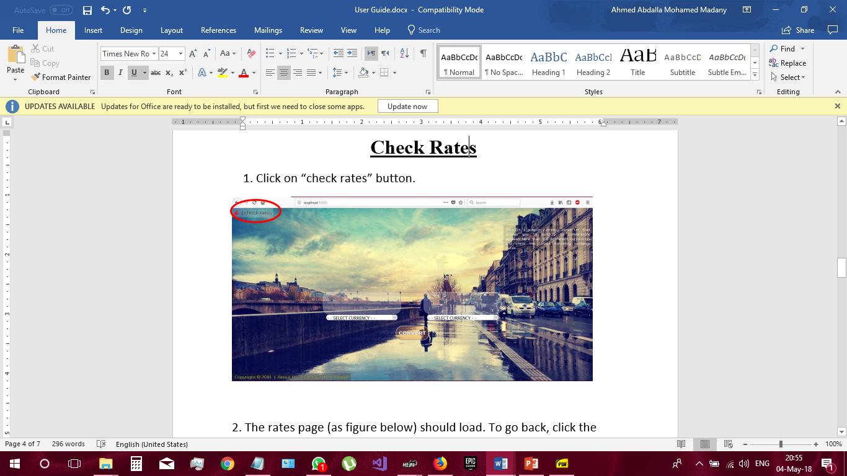

Figure :Check Rates

2. The rates page (as figure below) should load. To go back, click the “Back to the currency converter” button.

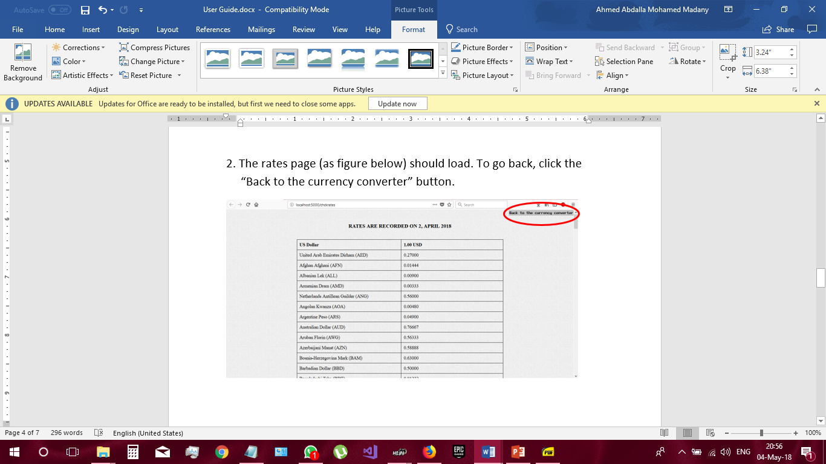

Figure :Back to Home Page

**About us**

1. Click on the “About US” button.

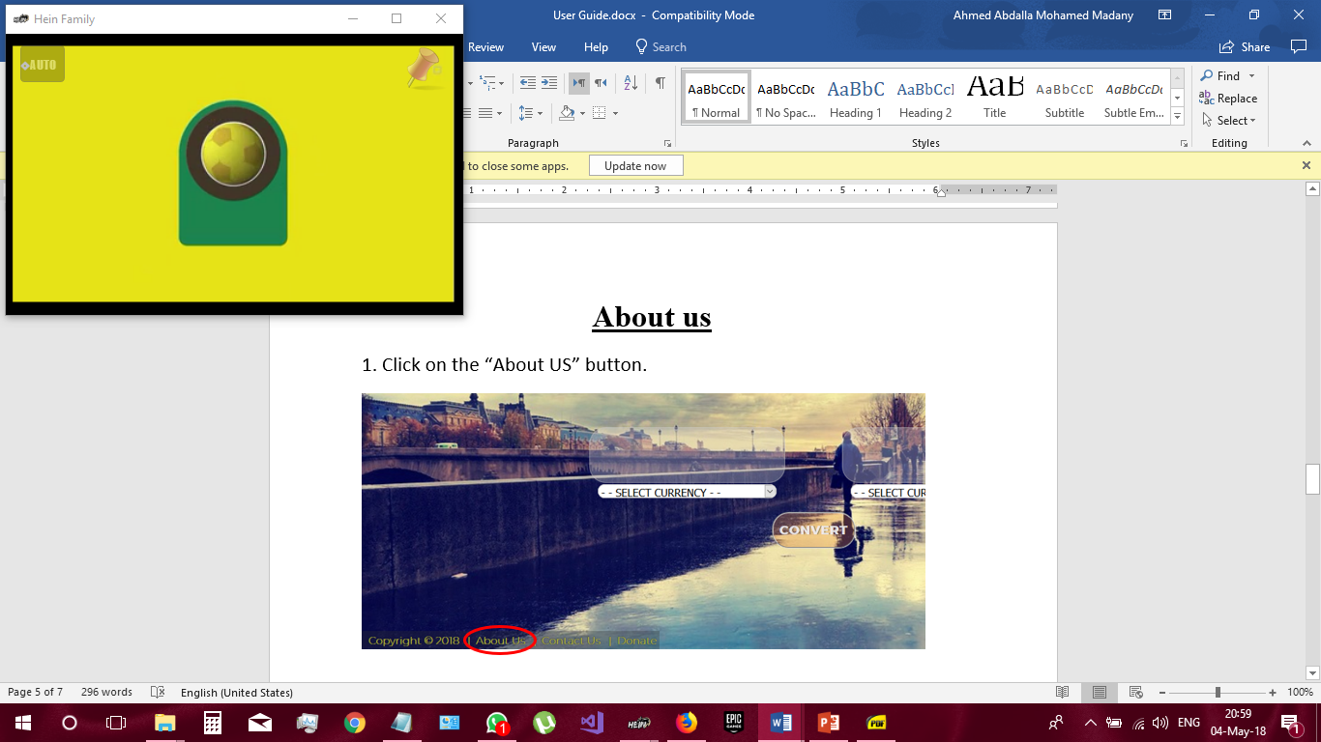

Figure :About Us

2. This should load the “About currency converter” page.

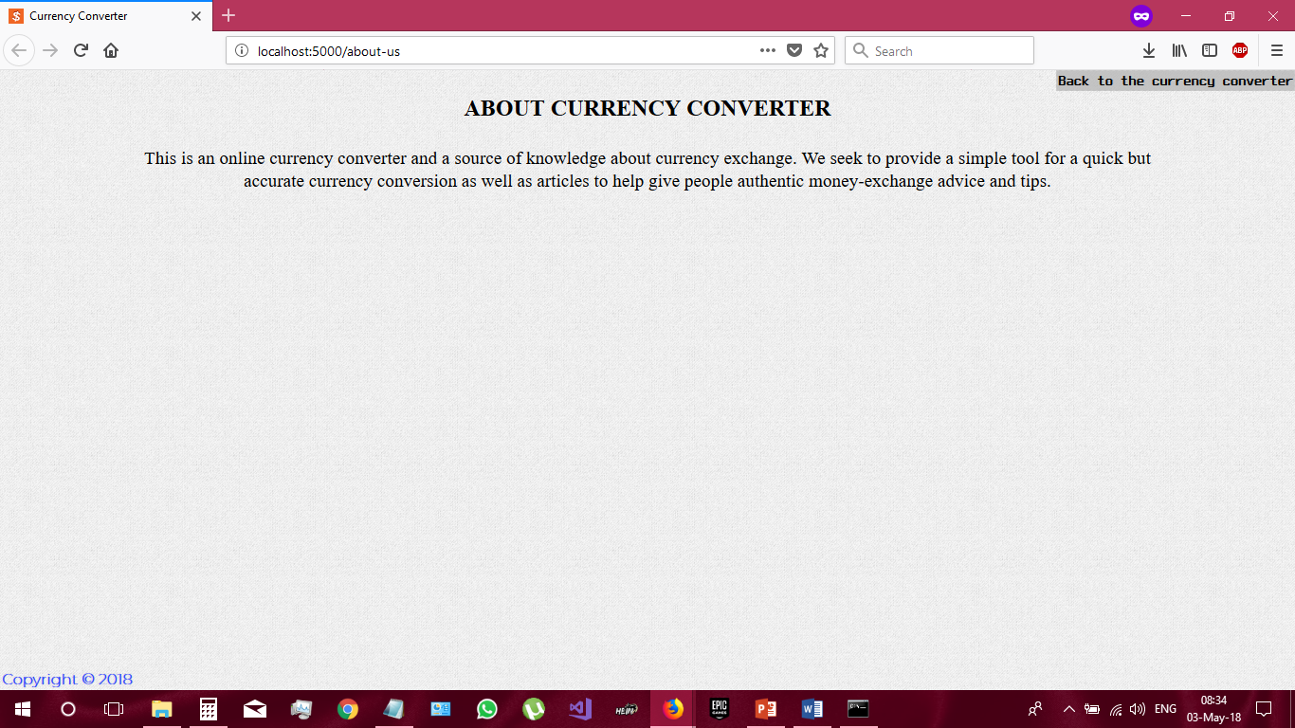

Figure : About Us Page

**Contact Us**

1. For any inquiries or issues, click on the “Contact Us” button circled in the figure below.

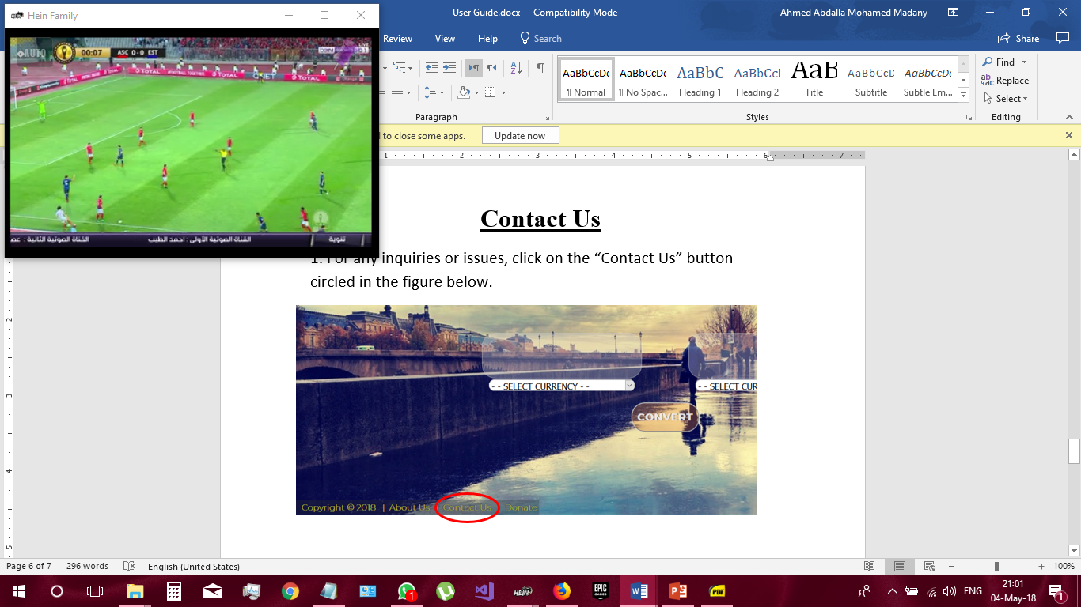

Figure :Contact Us

2. The contact page provides the e-mail address to contact.

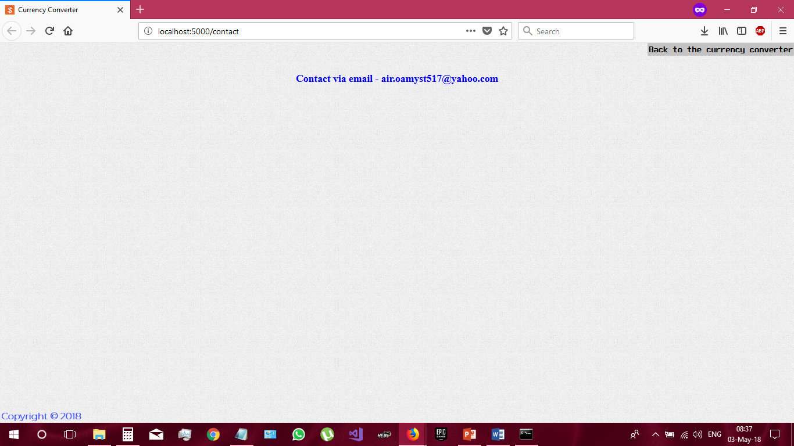

Figure : Contact via Email

**Donate**

1. To submit your donations, go to the donate page by clicking the “Donate” button.

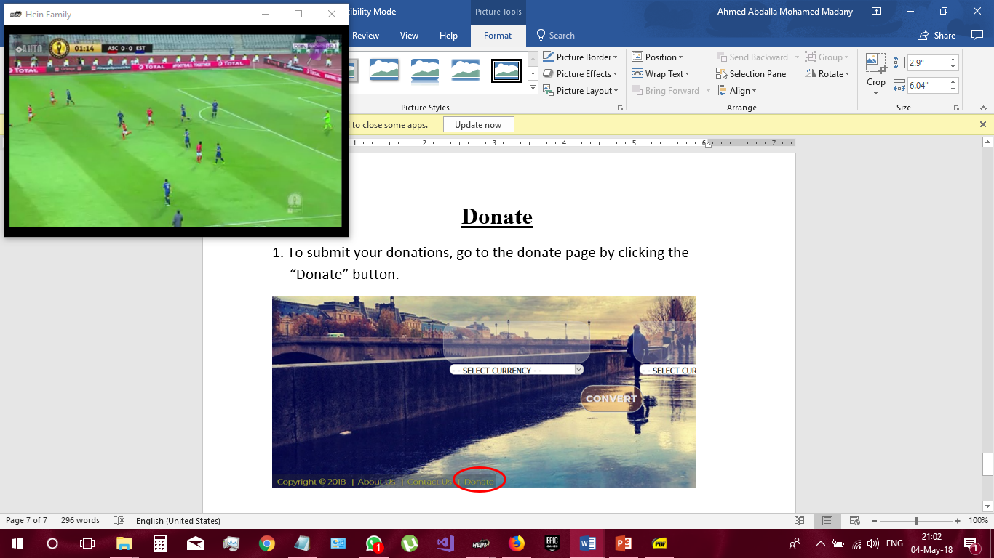

Figure :Donate

2. Enter the amount you wish to donate, then click on “Donate”.



Figure : Use donate option